2.OPERATORS, DATATYPES, ETC.

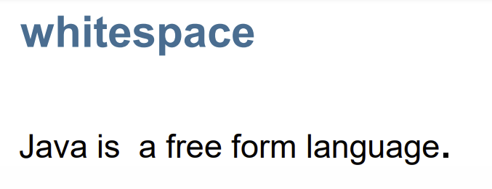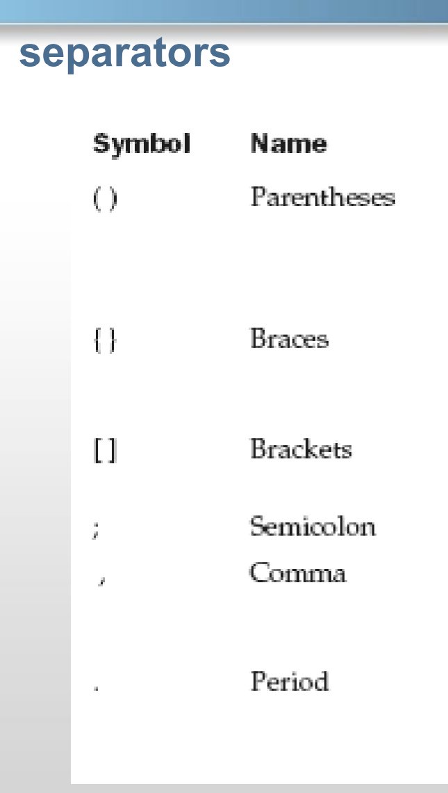

Keywords:

Reserved words that have a specific meaning and purpose.

Simple Data Types:

1. Byte
2. Short
3. Int integers



1. Long
2. Char (also String) 🡪words,letters,symbols,sentences
3. float
4. Double 🡪decimal values



1. Boolean🡪true/false

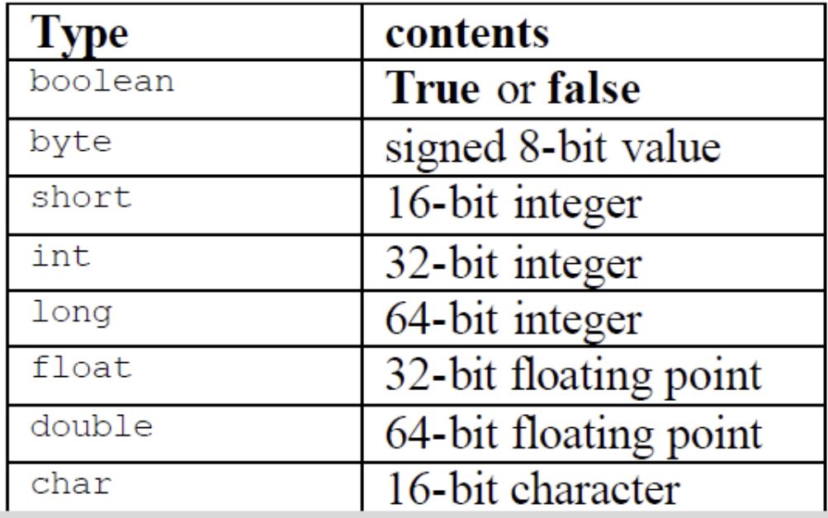

RANGE:

* Long= - 264 to +264
* Float= - 232 to +232
* Int= -232 to +232
* Short= -216 to 216
* Byte= -28 to +28

INTEGER LITERALS:

* Binary🡪0,1
* Decimal🡪0,1,2,3,4,5,6,7,8,9
* Octal🡪0,1,2,3,4,5,6,7
* Hexadecimal🡪0,1,2,3,4,5,6,7,8,9, A,B,C,D,E

FLOATING-POINT LITERALS:

1. Standard notation: integers and decimals
2. Scientific notation:has an ‘e’ followed by a decimal number.eg:66.022E23 , 1234E05

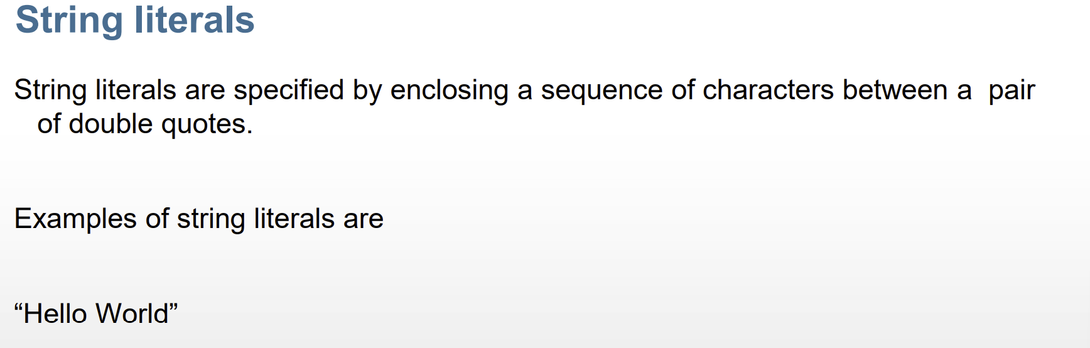

Declaring a variable:

OPERATORS:

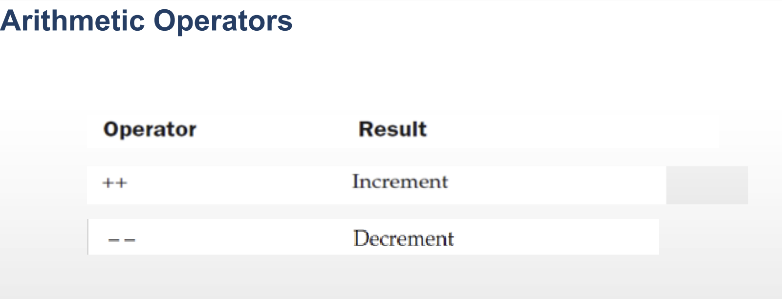

DIFFERENCE BETWEEN POST INCREMENT AND POST INCREMENT:

* a++, ++a, a--, --a

🡪Modulus Operator:

🡪Arithmetic Compound assignment operators:

* a+=5; c+=a\*b; etc.

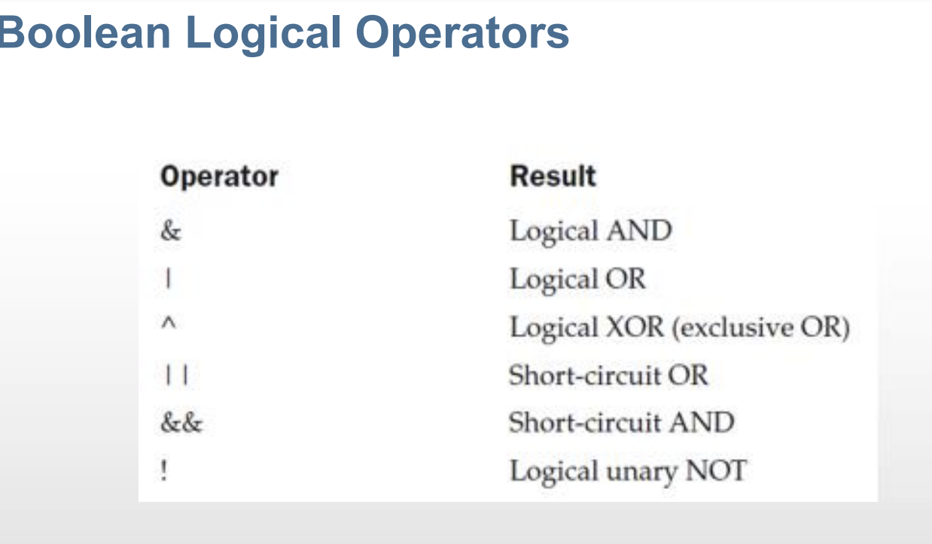

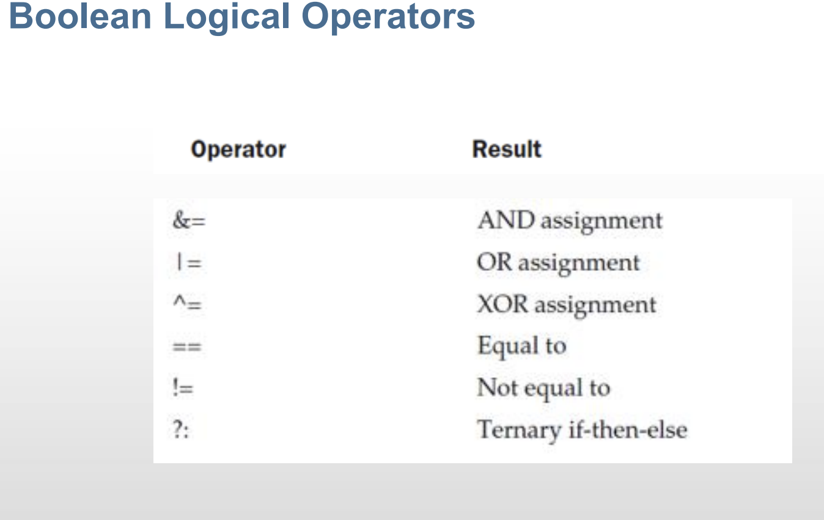

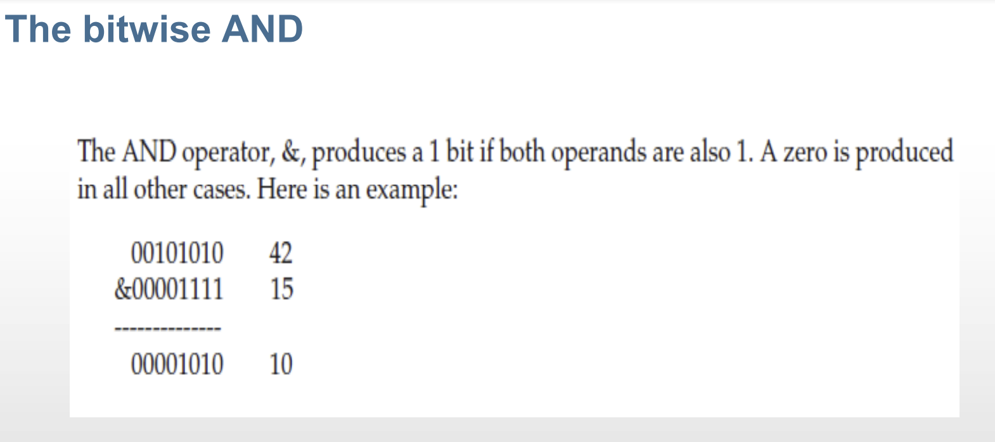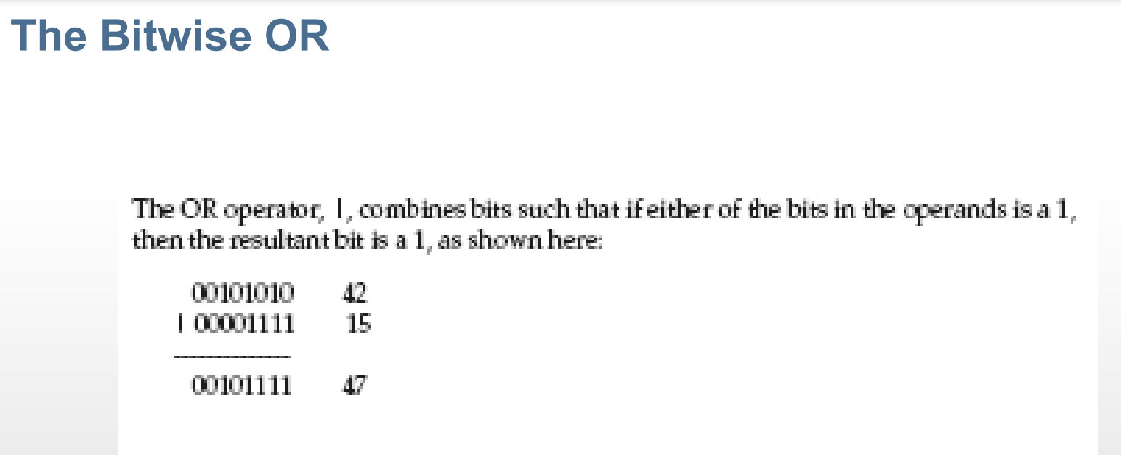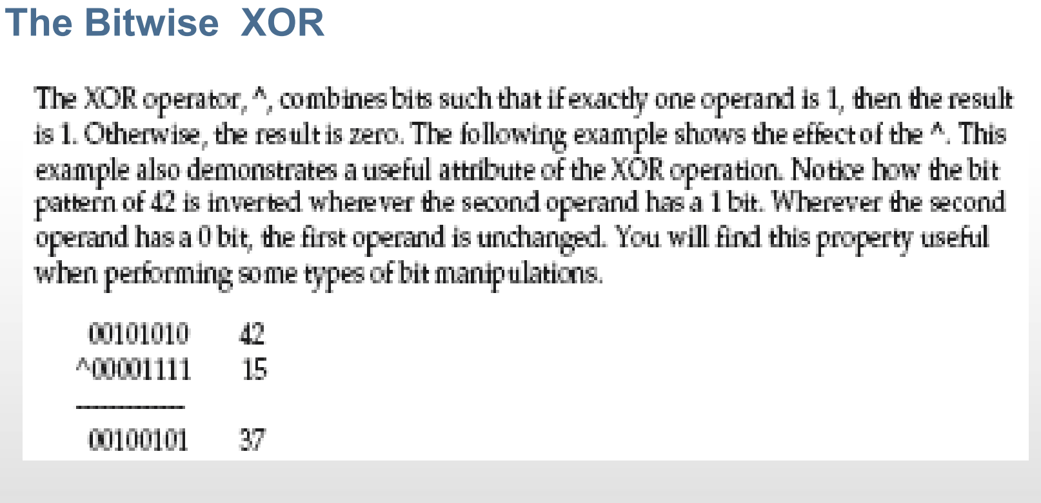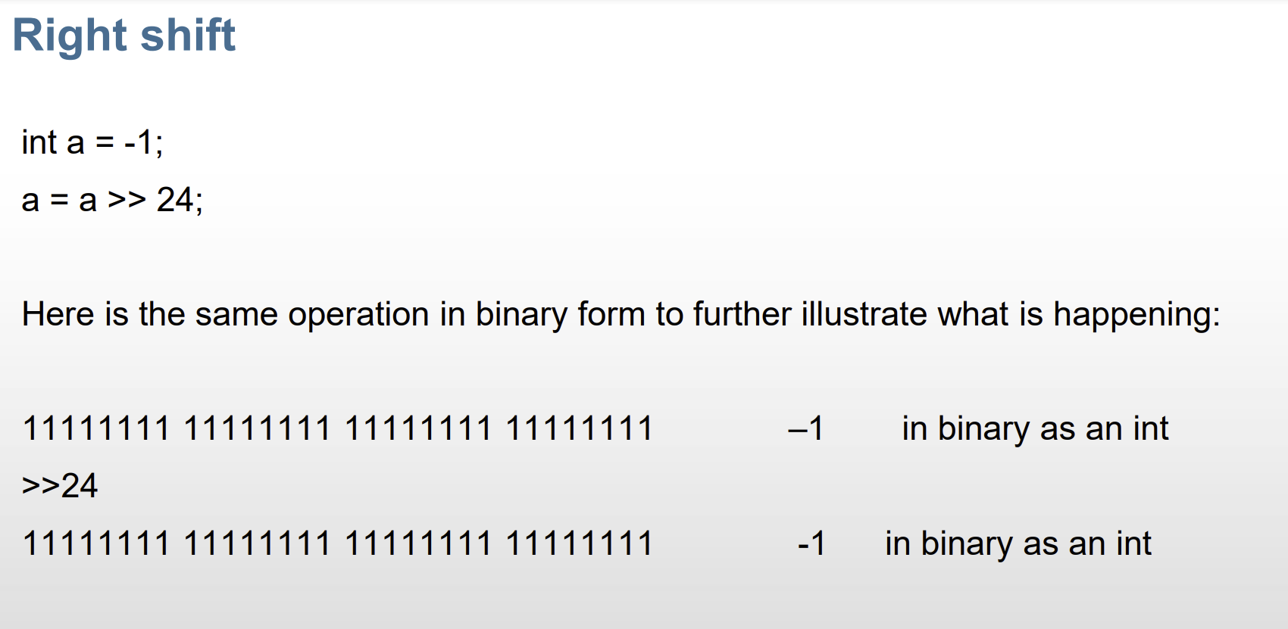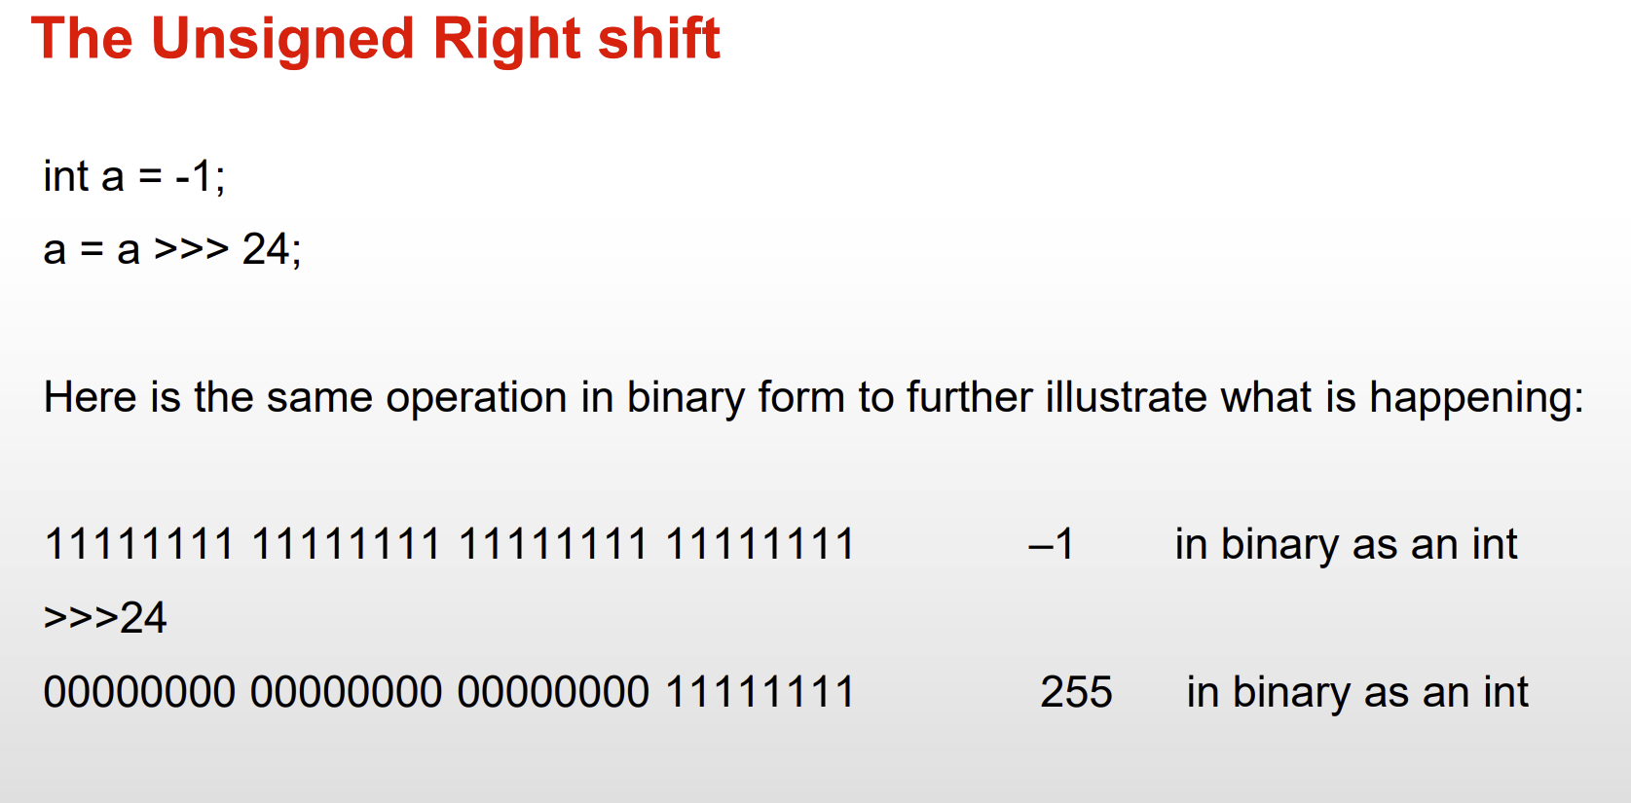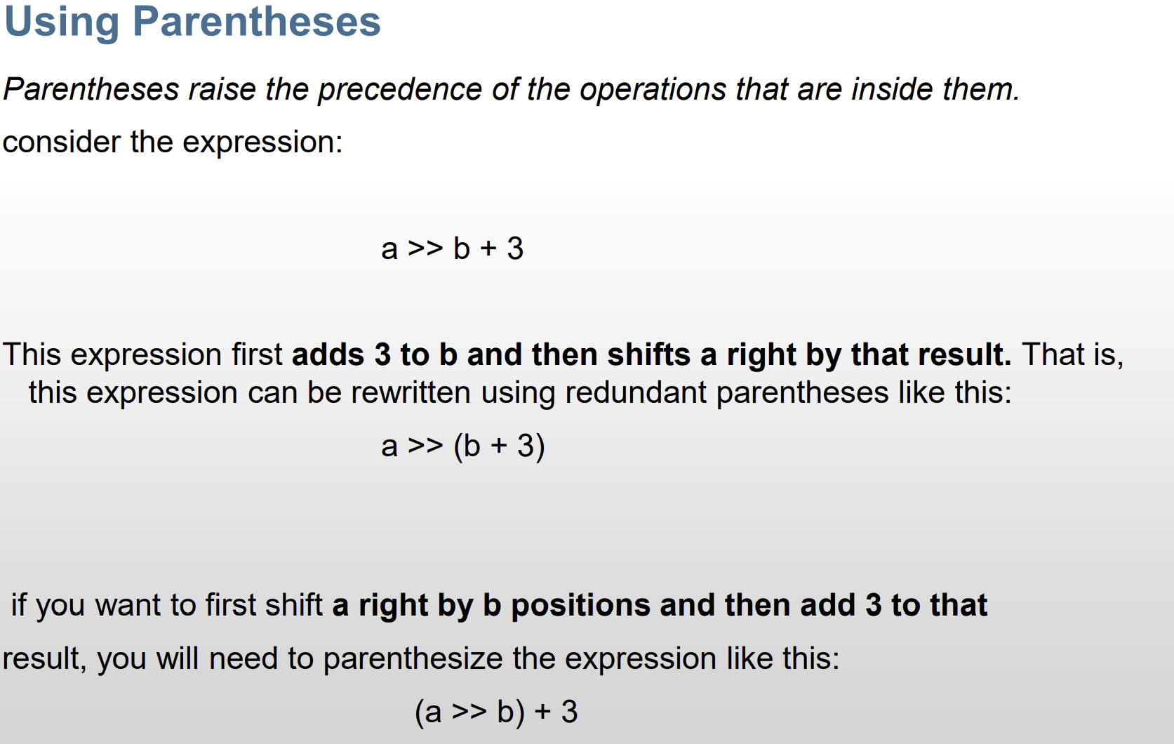

Dry run: